Main goal: update heart rate data and battery level data in the specific time interval

Key word to search: timer, app_timer

Method: using timer; using the inner clock to count, once the timer expires (e.g. 2 seconds later), the timeout handler(function) is called and executed.



1)Timer defined:



2)setting time interval

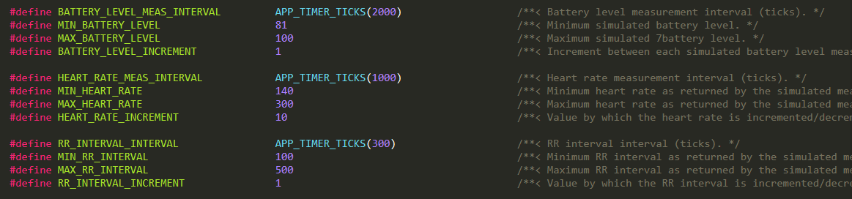

3)define timeout handler

Inside the handler, the data is updated and sent.

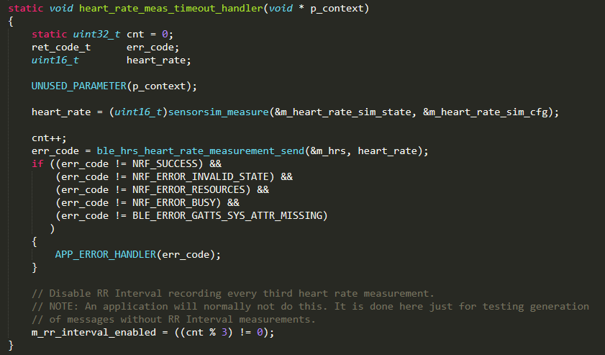

In this example, the simulator is used to generate the heart rate data. In real application, we can simply replace it with our real time data.

4)initialing the timer (linking timer, timer intervals and timeout handler)

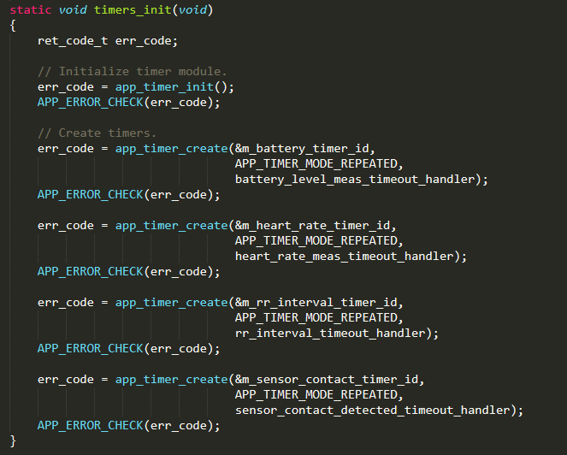

5)start the timer in main function

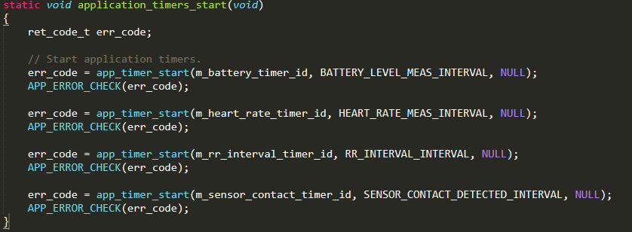

In main:



